C++ code

#include <iostream>
#include <string>
#include <stack>
#include <queue>
#include <limits>
using namespace std;

// Driver Request class
class DriverRequest {
public:
int id;
string name;
string vehicle;
int fare;
float rating;
int earnings;

DriverRequest(int id = 0, string name = "", string vehicle = "", int fare = 0)
: id(id), name(name), vehicle(vehicle), fare(fare), rating(0.0), earnings(0) {}

void display() {
cout << "\nDriver ID: " << id
<< "\nName: " << name
<< "\nVehicle: " << vehicle
<< "\nFare: " << fare << " PKR"
<< "\nRating: " << (rating > 0 ? to_string(rating) : "No ratings yet") << "\n";
}
};

// Passenger Class
class Passenger {
private:
string name;
string pickup;
string dropoff;
int walletBalance = 1000;
stack<DriverRequest> rideHistory;
queue<DriverRequest> driverQueue;
bool rideOngoing = false;
DriverRequest currentDriver;

public:
void registerPassenger() {
cout << "Enter your name: ";
getline(cin, name);
cout << "Enter pickup location: ";
getline(cin, pickup);
cout << "Enter dropoff location: ";
getline(cin, dropoff);
}

void addDriverRequests() {
driverQueue.push(DriverRequest(1, "Flinton", "Suzuki", 300));
driverQueue.push(DriverRequest(2, "Frenny", "Toyota", 450));
driverQueue.push(DriverRequest(3, "Glevin", "Honda", 400));
}

void showDrivers() {
cout << "\nAvailable Drivers:\n";
queue<DriverRequest> temp = driverQueue;
while (!temp.empty()) {
temp.front().display();
temp.pop();
}
}

void selectDriver() {
if (rideOngoing) {
cout << "\nYou already have a ride in progress. Cancel or complete it first.\n";
return;
}

int selectedID;
cout << "\nEnter Driver ID to book a ride: ";
cin >> selectedID;

bool found = false;
int size = driverQueue.size();
for (int i = 0; i < size; i++) {
DriverRequest dr = driverQueue.front();
driverQueue.pop();
if (dr.id == selectedID) {
if (walletBalance >= dr.fare) {
cout << "\nRide started with " << dr.name << "!\n";
walletBalance -= dr.fare;
dr.earnings += dr.fare;
currentDriver = dr;
rideHistory.push(dr);
rideOngoing = true;
found = true;
} else {
cout << "Insufficient wallet balance!\n";
driverQueue.push(dr);
return;
}
} else {
driverQueue.push(dr);
}
}

if (!found) {
cout << "Driver not found!\n";
}
}

void cancelRide() {
if (!rideOngoing) {
cout << "\nNo ride to cancel.\n";
return;
}

const int penalty = 50;
cout << "\nCancelling ride with " << currentDriver.name << ". Penalty: " << penalty << " PKR\n";
if (walletBalance >= penalty) {
walletBalance -= penalty;
} else {
walletBalance = 0;
}

rideOngoing = false;
currentDriver = DriverRequest();
}

void rateDriver() {
if (!rideOngoing) {
cout << "\nNo ride to rate.\n";
return;
}

float rating;
cout << "\nRate your driver (1 to 5): ";
cin >> rating;

if (rating >= 1 && rating <= 5) {
currentDriver.rating = rating;
cout << "Thanks for rating!\n";
} else {
cout << "Invalid rating!\n";
}

rideOngoing = false;
currentDriver = DriverRequest();
}

void simulateDriverLocation() {
if (!rideOngoing) {
cout << "\nNo ongoing ride.\n";
return;
}

cout << "\nTracking driver " << currentDriver.name << "'s location...\n";
cout << "Driver is 5 minutes away...\n";
cout << "Driver is 2 minutes away...\n";
cout << "Driver has arrived!\n";
}

void showWallet() {
cout << "\nYour wallet balance: " << walletBalance << " PKR\n";
}

void viewTripHistory() {
if (rideHistory.empty()) {
cout << "\nNo trips yet.\n";
return;
}

cout << "\nYour Trip History:\n";
stack<DriverRequest> temp = rideHistory;
while (!temp.empty()) {
temp.top().display();
temp.pop();
}
}

void showPassengerInfo() {
cout << "\nPassenger: " << name;
cout << "\nPickup: " << pickup;
cout << "\nDropoff: " << dropoff << endl;
}
};

// MAIN
int main() {
Passenger p;
p.registerPassenger();
p.addDriverRequests();

int choice;
do {
cout << "\nMenu:\n"
<< "1. Show Drivers\n"
<< "2. Select Driver\n"
<< "3. View Trip History\n"
<< "4. Show Passenger Info\n"
<< "5. Cancel Ride\n"
<< "6. Rate Driver\n"
<< "7. Simulate Driver Location\n"
<< "8. Show Wallet\n"
<< "9. Exit\nChoice: ";
cin >> choice;
cin.ignore(numeric_limits<streamsize>::max(), '\n'); // Flush buffer

switch (choice) {
case 1: p.showDrivers(); break;
case 2: p.selectDriver(); break;
case 3: p.viewTripHistory(); break;
case 4: p.showPassengerInfo(); break;
case 5: p.cancelRide(); break;
case 6: p.rateDriver(); break;
case 7: p.simulateDriverLocation(); break;
case 8: p.showWallet(); break;
case 9: cout << "Exiting...\n"; break;
default: cout << "Invalid choice.\n";
}
} while (choice != 9);

return 0;
}

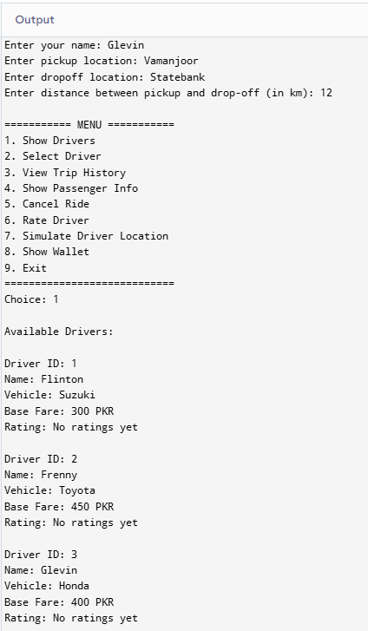
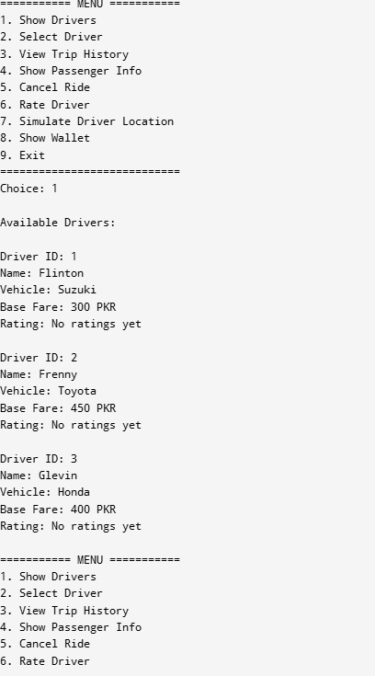
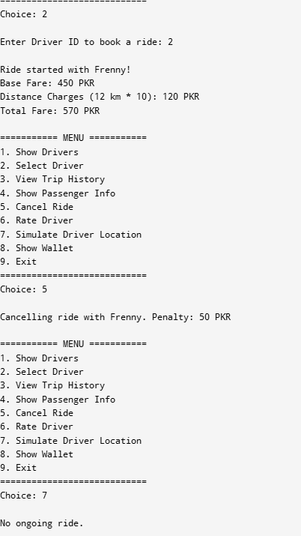
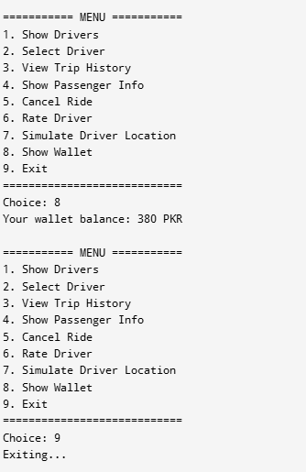Report

The program uses concepts such as encapsulation, and can be extended to demonstrate polymorphism, inheritance, and operator overloading effectively. Here's how each concept applies:

Encapsulation
Encapsulation is the technique of bundling data and methods that operate on that data within a single class, while keeping some elements private to protect internal state. In this system, encapsulation is used in the Passenger class where sensitive data such as walletBalance, rideHistory, and driverQueue are declared as private. These members are not directly accessible from outside the class, ensuring data protection. Instead, access is provided through public methods like selectDriver(), viewTripHistory(), and showWallet(). This controlled interaction enforces security, reduces errors, and simplifies code maintenance.

Polymorphism
Polymorphism allows objects to be treated as instances of their parent class rather than their actual class, enabling dynamic behavior. Though the current implementation doesn’t directly use polymorphism, it is highly applicable for fare calculations. For example, a base class Driver can have a virtual function calculateFare(), and derived classes such as StandardDriver, LuxuryDriver, or PromoDriver can override it to provide different fare logic. This allows the system to use the same interface while changing behavior at runtime, making the fare system flexible and extensible without altering core functionality.

Inheritance
Inheritance enables the creation of a new class from an existing class, inheriting its properties and behaviors. Although your code uses only a Passenger class, it can be enhanced by introducing a base class User containing shared attributes like name and common methods such as showInfo(). The Passenger class and a potential Driver class can then inherit from User, eliminating code repetition and promoting reusability. This hierarchy helps organize code better and makes it easier to add new user roles like Admin or FleetManager in the future.

Operator Overloading
Operator overloading lets you redefine the functionality of standard operators (such as +, -, ==, or >) for user-defined types. This feature is not currently implemented in your code but would be a valuable addition. For example, you can overload the + operator in the DriverRequest class to combine earnings from two driver objects, or overload the > operator to compare drivers based on their ratings. This improves code readability and allows operations involving custom objects to work more intuitively, similar to built-in types.

Example:

DriverRequest operator+(const DriverRequest& other) {
DriverRequest result;
result.earnings = this->earnings + other.earnings;
return result;
}

Conclusion
In conclusion, the ride-hailing system demonstrates a solid foundation in object-oriented programming through its use of encapsulation and provides a strong opportunity to incorporate other key OOP concepts such as inheritance, polymorphism, and operator overloading. Encapsulation ensures data security and controlled access, making the system reliable and maintainable. With minor enhancements, polymorphism can introduce dynamic fare calculation, inheritance can simplify user role management, and operator overloading can make object interactions more intuitive. Together, these principles not only improve the code’s structure and readability but also make it scalable for real-world applications where flexibility and reusability are essential.

